**Practical No: 1**

**Aim:** Install and understand Docker container, Node.js, Ethereum and perform necessary software installation on local machineWhat is docker?

* **Docker:** Docker is a containerization platform that packages your application and all its dependencies together in the form of a docker container to ensure that your application works seamlessly in any environment.
* **Container:** Docker Container is a standardized unit which can be created on the fly to deploy a particular application or environment. It could be an Ubuntu container, CentOs container, etc. to fullfill the requirement from an operating system point of view. Also, it could be an application oriented container like CakePHP container or a Tomcat-Ubuntu container etc.
* **Node.js:** Node.js is an open-source, cross-platform, back-end JavaScript runtime environment that runs on a JavaScript Engine (i.e. V8 engine) and executes JavaScript code outside a web browser, which was designed to build scalable network applications. Node.js lets developers use JavaScript to write command line tools and for server-side scripting— running scripts server-side to produce dynamic web page content before the page is sent to the user's web browser.
* **Ethereum:** Ethereum is a decentralized, open-source blockchain with smart contract functionality. Ether is the native cryptocurrency of the platform. Among cryptocurrencies, ether is second only to bitcoin in market capitalization. Ethereum was conceived in 2013 by programmer Vitalik Buterin.
* **Remix IDE:** Remix IDE is an open source web and desktop application. It fosters a fast development cycle and has a rich set of plugins with intuitive GUIs. Remix is used for the entire journey of contract development with Solidity language as well as a playground for learning and teaching Ethereum.<https://labs.play-with-docker.com/>

**Steps:**

**Step0:-**

**A. Docker container (Web Based)**

1. Open your browser and go to https://labs.play-with-docker.com/, then play with docker page will open up here click on login button and select docker option.
2. Now new sign up page will occur on new window, here click on “Sign Up” option from top right corner and fill up the details to create a docker account and click sign up button to proceed.
3. After the sign-up process you get back to a main Log In page. Now just fill your Login Credentials and click on continue now select the $0 personal plan on next page to continue free.
4. Then click on Start button, after you click on start button your free docker session gets started.

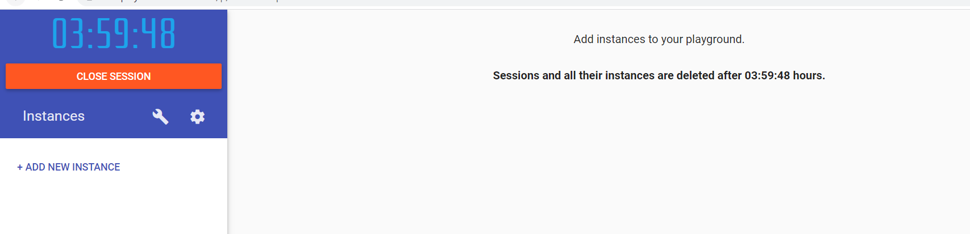

1. Now in docker playground for the web based docker container click on ADD NEW INSTANCE and get the instance as shown below

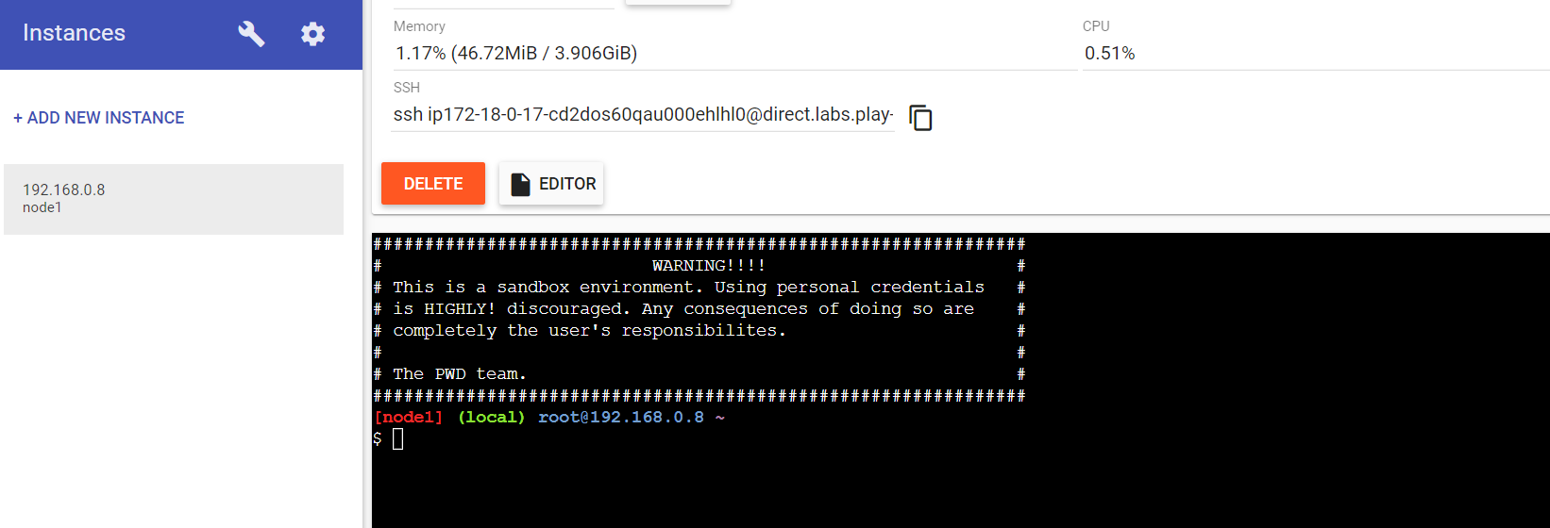

.

**Step1:-** $docker –version

$docker pull rocker/verse or busybox

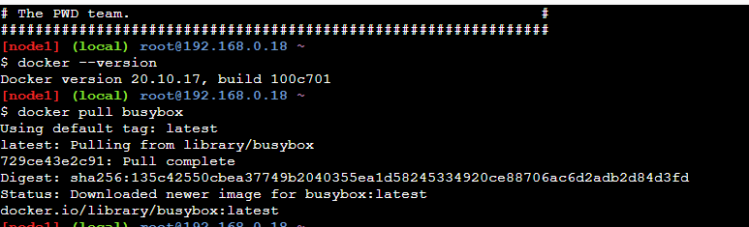

**Step2:-** $docker images - check image file

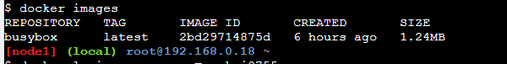

**Step3:-** go to the link and Login In with docker account, then in docker hub page click on “Create a Repository” option. <https://hub.docker.com/>

* Now give repository a name, small description and visibility as Public. Your repository will look like given below in second image after creation.

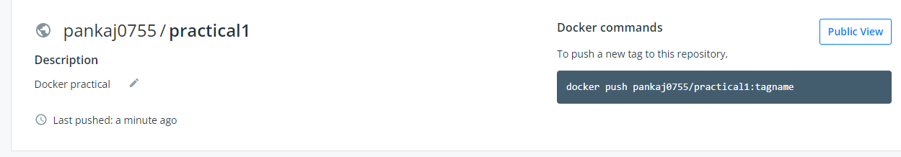

**Step4 :-** docker login --username=(your username) also give the password (shows invisible)> to connect with docker hub repository.

docker login --username=pankaj0755

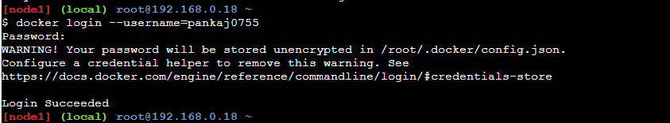

**Step5:-** docker tag (IMAGE ID) (Username/repo name):t1 > for tagging the repository

**$docker tag image_Id/pankaj0755/practical1:tagname**



**Step 6:-** docker push (Username/repo name):t1 > pushing tag to repository

**$docker push pankaj0755/practical1:tagname**

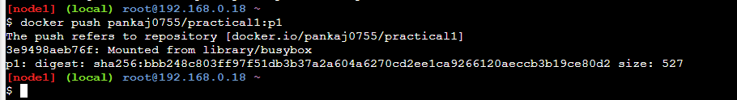

**Step7:-** After the successful tagging, in Tags and scans section of docker hub you can see the tagged

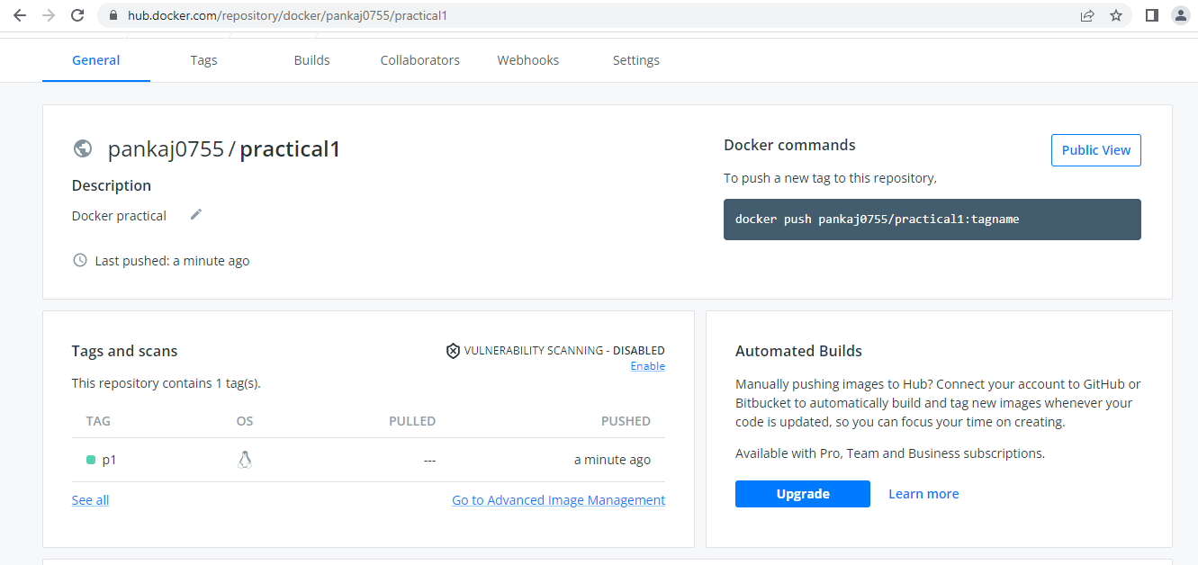

**B. Node.js**

* Install the stable recommend Node.js version

**Inbuild module Program**

1. For that first create the notepad file and add the below code and save it as myfirst.js:

var http = require("http");

http.createServer(function(req,res)

{

res.writeHead(200,{'Content-Type':'text/html'});

res.end('Hello World');

}).listen(8081);

2. Now go to the file location where the file is created and open the command prompt or windows power shell and type node myfirst.js, if everything is correct you can see the command prompt as shown below

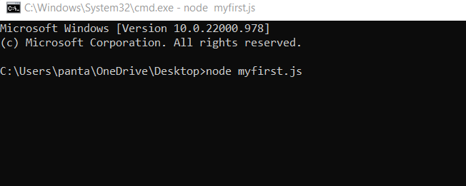

3. Now open your browser and type localhost (and port number which you given in code). Note: if 8081 port not working on your machine try changing it to 8082 or 8080

**Output:-**

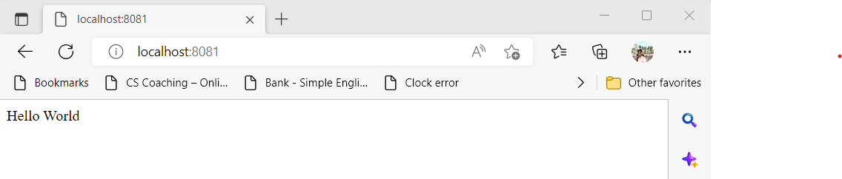

**User Define Code**

1. First create the module that returns the date using below code (save as myfirstmodule.js): exports.myDateTime = function()

{

return Date();

};

2. For main program code (save as main.js):

var http = require('http');

var dt = require('./myfirstmodule');

http.createServer(function (req, res){

res.writeHead (200,{'Content-Type':'text/html'});

res.write("The date and time are currently:" +dt.myDateTime());

res.end();

}).listen(8081);

3. Now go to the file location where the file is created and open the command prompt or windows power shell and type node main.js, if everything is correct you can see the command prompt as shown below.

4. Now open your browser and type localhost (and port number which you given in code). Note: if 8081 port not working on your machine try changing it to 8082 or 8080

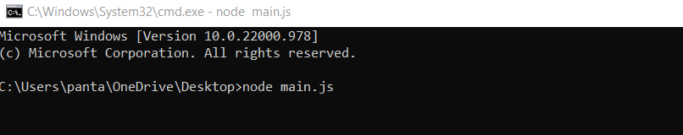

**Output:**

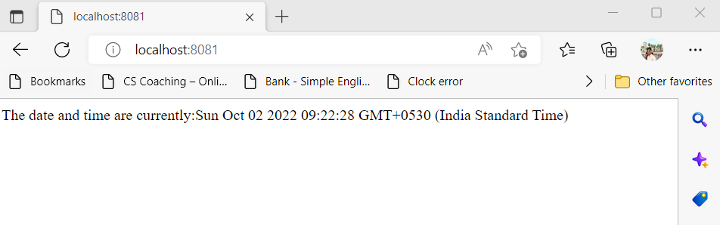

**C. Ethereum (Remix IDE)**

1. Go to https://remix.ethereum.org/

2. You get treated with Remix IDE for Ethereum coding.

3. You can checkout workspaces also located at left side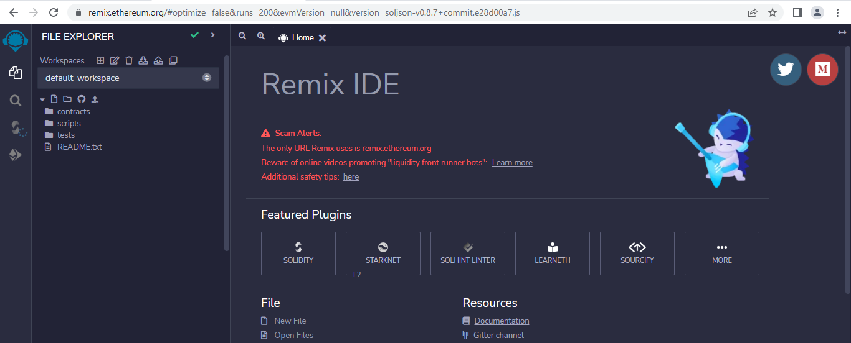

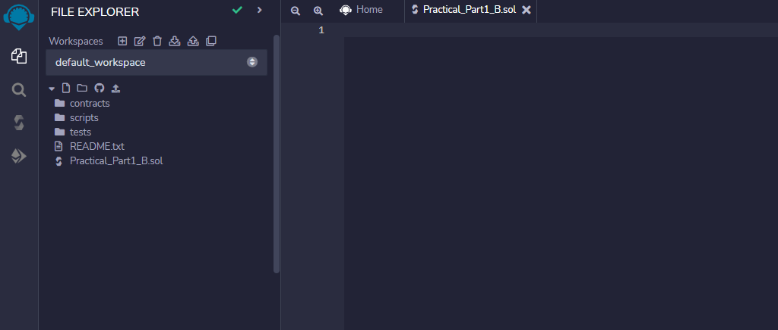

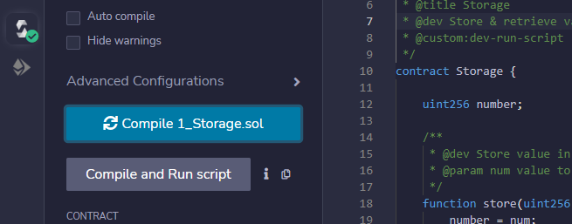

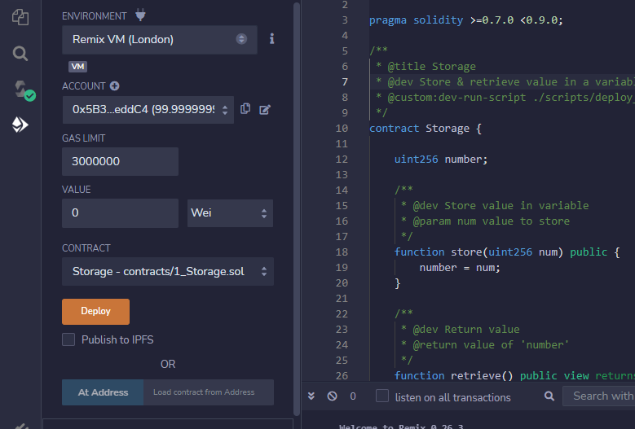

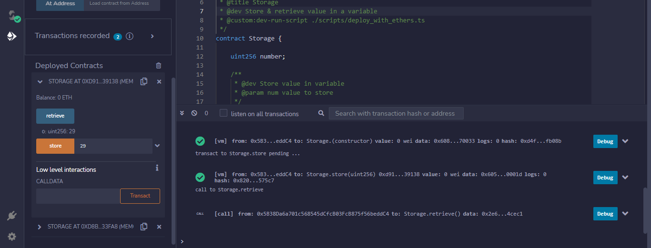

**Practical No. 2**

**Aim:** A Simple Client Class that generates the private And public keys by using the built in python RSA algorithm And test.

**Theory:**

The Rivest-Shamir-Adleman (RSA) encryption algorithm is an asymmetric encryption algorithm that is widely used in many products and services. Asymmetric encryption uses a key pair that is mathematically linked to encrypt and decrypt data. A private and public key are created, with the public key being accessible to anyone and the private key being a secret known only by the key pair creator. With RSA, either the private or public key can encrypt the data, while the other key decrypts it. This is one of the reasons RSA is the most used asymmetric encryption algorithm.

Prerequisite (For Google Colab):

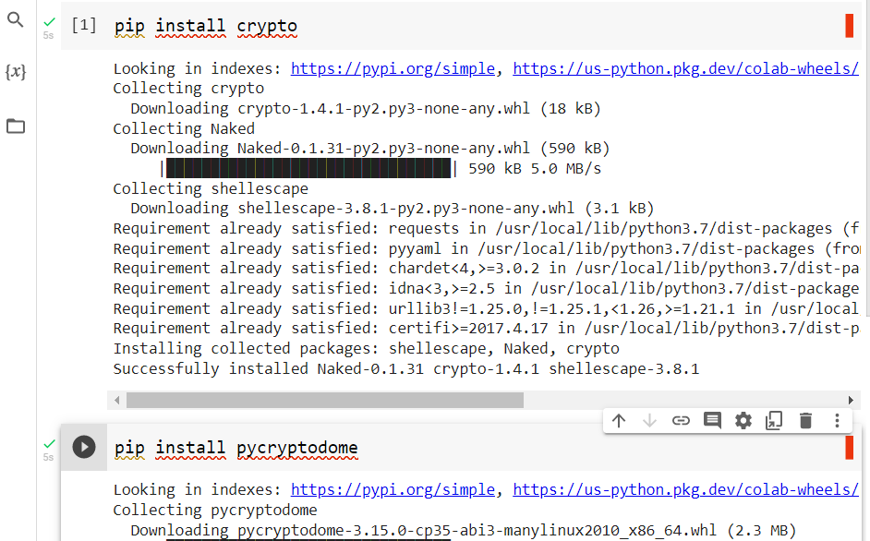

**#CODE**

import Crypto

import binascii

from Crypto.PublicKey import RSA

from Crypto.Signature import PKCS1_v1_5

class Client:

 def __init__(self):

   random = Crypto.Random.new().read

   self._private_key = RSA.generate(1024, random)

   self._public_key = self._private_key.publickey()

   self._signer = PKCS1_v1_5.new(self._private_key)

 @property

 def identity(self):

   return binascii.hexlify(self._public_key.exportKey(format='DER')).decode('ascii')

Pankaj = Client()

print ("Printing the result of Pankaj.identity as follows......\n",Pankaj.identity)

**#Output:-**

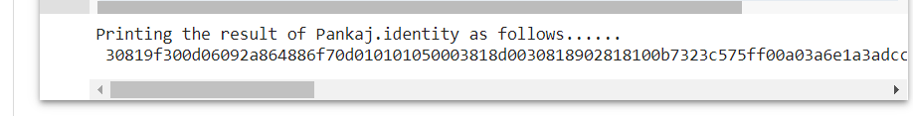

**Practical No: 3**

**Aim: A transaction class to send and receive money and test it.**

**Theory:** SHA is the acronym for Secure Hash Algorithm, used for hashing data and certificate files. Every piece of data produces a unique hash that is thoroughly non-duplicable by any other piece of data. The resulting digital signature is unique too as it depends on the hash that's generated out of the data

**Prerequisite (For Google Colab):**

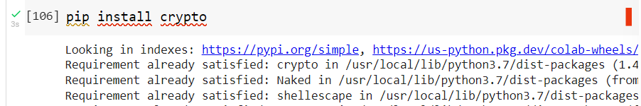

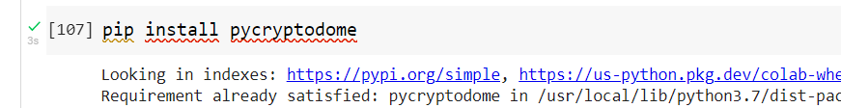

**#Code:**

import Crypto

import binascii

from Crypto.PublicKey import RSA

from Crypto.Signature import PKCS1_v1_5

import datetime

import collections

from Crypto.Hash import SHA

class Transaction:

  def __init__(self, sender, recipient, value):

    self.sender = sender

    self.recipient = recipient

    self.value = value

    self.time = datetime.datetime.now()

  def to_dict(self):

    if self.sender == "Genesis":

      identity = "Genesis"

    else:

      identity = self.sender.identity

    return collections.OrderedDict({

        'sender': identity,

        'recipient': self.recipient,

        'value': self.value,

        'time' : self.time})

  def sign_transaction(self):

      private_key = self.sender._private_key

      signer = PKCS1_v1_5.new(private_key)

      h = SHA.new(str(self.to_dict()).encode('utf8'))

      return binascii.hexlify(signer.sign(h)).decode('ascii')

class Client:

  def __init__(self):

    random = Crypto.Random.new().read

    self._private_key = RSA.generate(1024, random)

    self._public_key = self._private_key.publickey()

    self._signer = PKCS1_v1_5.new(self._private_key)

  @property

  def identity(self):

    return binascii.hexlify(self._public_key.exportKey(format='DER')).decode('ascii')

Pankaj = Client()

Pathak = Client()

t = Transaction(

 Pathak,

 Pankaj.identity,

 5.0)

signature = t.sign_transaction()

print ("Signature\n",signature)

**Output:-**

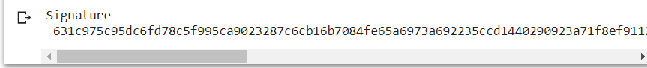

**Practical No: 4**

**Aim:** Create multiple transactions and display them.

**Theory:**

Transactions are data structures that encode the transfer of value between participants in the bitcoin system. Each transaction is a public entry in bitcoin's blockchain, the global double-entry bookkeeping ledger.

The transactions made by various clients are queued in the system; the miners pick up the transactions from this queue and add it to the block. They will then mine the block and the winning miner would have the privilege of adding the block to the blockchain and thereby earn some money for himself.

**Prerequisite (For Google Colab):**





**#CODE**

import Crypto

import binascii

from Crypto.PublicKey import RSA

from Crypto.Signature import PKCS1_v1_5

import datetime

import collections

from Crypto.Hash import SHA

class Transaction:

  def __init__(self, sender, recipient, value):

    self.sender = sender

    self.recipient = recipient

    self.value = value

    self.time = datetime.datetime.now()

  def to_dict(self):

    if self.sender == "Genesis":

      identity = "Genesis"

    else:

      identity = self.sender.identity

      return collections.OrderedDict({

          'sender': identity,

          'recipient': self.recipient,

          'value': self.value,

          'time' : self.time})

  def sign_transaction(self):

      private_key = self.sender._private_key

      signer = PKCS1_v1_5.new(private_key)

      h = SHA.new(str(self.to_dict()).encode('utf8'))

      return binascii.hexlify(signer.sign(h)).decode('ascii')

class Client:

    def __init__(self):

      random = Crypto.Random.new().read

      self._private_key = RSA.generate(1024, random)

      self._public_key = self._private_key.publickey()

      self._signer = PKCS1_v1_5.new(self._private_key)

    @property

    def identity(self):

      return binascii.hexlify(self._public_key.exportKey(format='DER')).decode('ascii')

print("Adding more clients to perform multiple transactions.........")

Ethan = Client()

Maria = Client()

Lucy = Client()

Chandler = Client()

t1 = Transaction( Ethan, Lucy.identity, 50.0)

signature = t1.sign_transaction()

print("\nsignature of the transaction done between Ethan(sender) and Lucy(receiver) is as follows\n",signature)

t2 = Transaction( Maria, Chandler.identity, 25.0)

signature = t2.sign_transaction()

print("\nsignature of the transaction done between Maria(sender) and Chandler(receiver) is as follows\n",signature)

**Output:-**

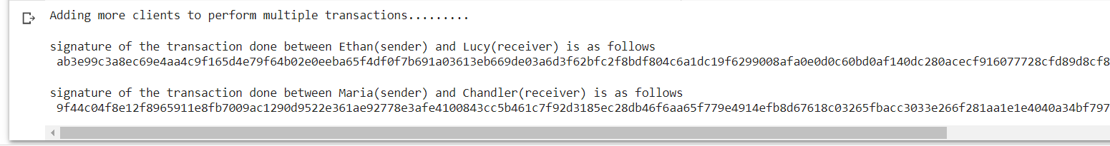

**Practical No: 5**

**Aim: Create a blockchain, a genesis block and execute it.**

**Theory:**

* **Blockchain:** A blockchain is a type of distributed ledger technology (DLT) that consists of growing list of records, called blocks, that are securely linked together using cryptography. Each block contains a cryptographic hash of the previous block, a timestamp, and transaction data (generally represented as a Merkle tree, where data nodes are represented by leafs). The timestamp proves that the transaction data existed when the block was created. Since each block contains information about the block previous to it, they effectively form a chain (compare linked list data structure), with each additional block linking to the ones before it. Consequently, blockchain transactions are irreversible in that, once they are recorded, the data in any given block cannot be altered retroactively without altering all subsequent blocks. Blockchains are typically managed by a peer-to-peer (P2P) computer network for use as a public distributed ledger, where nodes collectively adhere to a consensus algorithm protocol to add and validate new transaction blocks. Although blockchain records are not unalterable, since blockchain forks are possible, blockchains may be considered secure by design and exemplify a distributed computing system with high Byzantine fault tolerance.
* **Genesis:** block The genesis block is the first block in any blockchain-based protocol. It is the basis on which additional blocks are added to form a chain of blocks, hence the term blockchain. This block is sometimes referred to Block 0. Every block in a blockchain stores a reference to the previous block. In the case of Genesis Block, there is no previous block for reference. In technical terms, it means that the Genesis Block has it’s “previous hash” value set to 0. This means that no data was processed before the Genesis Block. All other blocks will have sequential numbers starting by 1, and will have a “previous hash” set to the hash of the previous block.

**Code:**

import hashlib

import datetime

class Block:

  def __init__(self, previous_block_hash, data, timestamp):

    self.previous_block_hash = previous_block_hash

    self.data = data

    self.timestamp = timestamp

    self.hash = self.get_hash()

  @staticmethod

  def create_genesis_block():

    return(Block("0", "0", datetime.datetime.now()))

  def get_hash(self):

    header = (str(self.previous_block_hash) +str(self.data) +str(self.timestamp))

    inner_hash = hashlib.sha256(header.encode()).hexdigest().encode()

    comp_hash = hashlib.sha256(inner_hash).hexdigest()

    return comp_hash

number_of_blocks = 14

Blockchain = [Block.create_genesis_block()]

print("Genesis Block is Created")

print("Hash: %s" % Blockchain[0].hash)

for i in range(1, number_of_blocks):

  Blockchain.append(Block(Blockchain[i-1].hash,"Block number %d" %i, datetime.datetime.now()))

  print("%d block created" %i)

  print("Hash: %s" % Blockchain[-1].hash)

**Output:-**

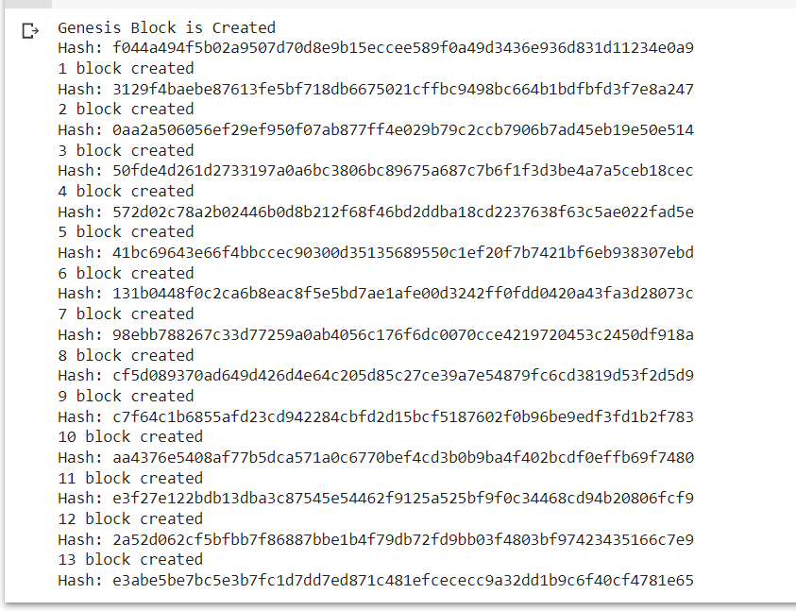

**Practical No: 6**

**Aim: Create a mining function and test it.**

**Theory:**

**Mining:** Mining is the process that Bitcoin and several other cryptocurrencies use to generate new coins and verify new transactions. It involves vast, decentralized networks of computers around the world that verify and secure blockchains – the virtual ledgers that document cryptocurrency transactions. In return for contributing their processing power, computers on the network are rewarded with new coins. It’s a virtuous circle: the miners maintain and secure the blockchain, the blockchain awards the coins, the coins provide an incentive for the miners to maintain the blockchain.

**Code:**

from hashlib import sha256

MAX_NONCE = 100000000000

def SHA256(text):

  return sha256(text.encode("ascii")).hexdigest()

def mine(block_number, transactions, previous_hash, prefix_zeros):

  prefix_str = '0' *prefix_zeros

  for nonce in range(MAX_NONCE):

    text = str(block_number) + transactions + previous_hash + str(nonce)

    new_hash = SHA256(text)

    if new_hash.startswith (prefix_str):

      print(f"Yay! Successfully mined bitcoins with nonce value:{ nonce}")

    return new_hash

  raise BaseException(f"Couldn't find correct has after trying (MAX_NONCE) limes")

  if __name__ == "__main__":

    transactions='''

    Dhaval->Bhavin->20,

    Mando->Cara->45

    '''

    difficulty=4

import time

start = time.time()

print("start mining")

new_hash = mine(5, transactions, '0000000xa036944e29568d0cff17edbe038f81208fecf9a66be9a2b8321c6ec7', difficulty)

total_time = str((time.time() -start))

print(f"end mining. Mining took: {total_time} seconds")

print(new_hash)

Output:-

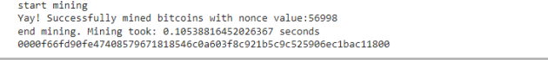

**Practical No: 7**

**Aim: Add blocks to the miner and dump the blockchain.**

**Theory:** A blockchain is a decentralized ledger of all transactions across a peer-to-peer network. Using this technology, participants can confirm transactions without a need for a central clearing authority.

**Code:-**

import datetime

import hashlib

class Block:

  blockNo = 0

  data = None

  next = None

  hash = None

  nonce = 0

  previous_hash = 0x0

  timestamp = datetime.datetime.now()

  def __init__(self, data):

    self.data = data

  def hash(self):

    h = hashlib.sha256()

    h.update(

        str(self.nonce).encode('utf-8') +

        str(self.data).encode('utf-8') +

        str(self.previous_hash).encode('utf-8') +

        str(self.timestamp).encode('utf-8') +

        str(self.blockNo).encode('utf-8')

        )

    return h.hexdigest()

  def __str__(self):

    return "Block Hash: " + str(self.hash()) + "\nBlockNo: " + str(

self.blockNo) + "\nBlock Data: " + str(self.data) + "\nHashes: " + str(

self.nonce) + "\n--------------"

class Blockchain:

  diff = 20

  maxNonce = 2**32

  target = 2 ** (256-diff)

  block = Block("Genesis")

  dummy = head = block

  def add(self, block):

    block.previous_hash = self.block.hash()

    block.blockNo = self.block.blockNo + 1

    self.block.next = block

    self.block = self.block.next

  def mine(self, block):

   for n in range(self.maxNonce):

     if int(block.hash(), 16) <= self.target:

       self.add(block)

       print(block)

       break

     else:

       block.nonce += 1

blockchain = Blockchain()

for n in range(10):

  blockchain.mine(Block("Block " + str(n+1)))

while blockchain.head != None:

  print(blockchain.head)

  blockchain.head = blockchain.head.next

Output:-

Block Hash: 67a42937b01a3328aca1ee685e26bc8ef192e3de8584142892a9a78d43dfcbac

BlockNo: 1

Block Data: Block 1

Hashes: 3630387

--------------

Block Hash: 1ad1df93868a7740560acf71938343412afd8c88283047971fecbcd72dc6a24f

BlockNo: 2

Block Data: Block 2

Hashes: 358818

--------------

Block Hash: d0df8bd38f9479970e3e51a7c70b353b2163b38866a2146c74f604c23a439dce

BlockNo: 3

Block Data: Block 3

Hashes: 3229484

--------------

Block Hash: a82629bf4f0648c71145491f6054d814fe7d03bd56e0d0c11cd082e139e510e0

BlockNo: 4

Block Data: Block 4

Hashes: 4435

--------------

Block Hash: 2fff7b1ea679d975e3e2668239a0054fd6e44e291ebd652a632c91924dfe17c9

BlockNo: 5

Block Data: Block 5

Hashes: 294780

--------------

Block Hash: c8bbf6be119e90fd4baeba2744f6b412f02e46d95c0c4ab5933b690875c6eca9

BlockNo: 6

Block Data: Block 6

Hashes: 460826

--------------

Block Hash: 4edb1d96832edd6fb6bc9ffa6b9fda2c395ec6983e2c99da5deaf7b7c468a7e4

BlockNo: 7

Block Data: Block 7

Hashes: 1929340

--------------

Block Hash: 45ed9b2f49c20cabbf5aa734f46a3dbae93fc4618418e108771683b2bbf00512

BlockNo: 8

Block Data: Block 8

Hashes: 1665985

--------------

Block Hash: a7f0d3e4c34871db193a77c47d39fcb44c9324e8dcbd69e25c51efdf5c77a6f8

BlockNo: 9

Block Data: Block 9

Hashes: 361489

--------------

Block Hash: 18235b03dc74c5e6b010e4355a47dadceeb14803ff6721a2567b013d672d0330

BlockNo: 10

Block Data: Block 10

Hashes: 177757

--------------

Block Hash: a3fac650f838b387c77afbf1c13bf4d4df68d6e5c541c9d412d7d550e4e284c9

BlockNo: 0

Block Data: Genesis

Hashes: 0

--------------

Block Hash: 67a42937b01a3328aca1ee685e26bc8ef192e3de8584142892a9a78d43dfcbac

BlockNo: 1

Block Data: Block 1

Hashes: 3630387

--------------

Block Hash: 1ad1df93868a7740560acf71938343412afd8c88283047971fecbcd72dc6a24f

BlockNo: 2

Block Data: Block 2

Hashes: 358818

--------------

Block Hash: d0df8bd38f9479970e3e51a7c70b353b2163b38866a2146c74f604c23a439dce

BlockNo: 3

Block Data: Block 3

Hashes: 3229484

--------------

Block Hash: a82629bf4f0648c71145491f6054d814fe7d03bd56e0d0c11cd082e139e510e0

BlockNo: 4

Block Data: Block 4

Hashes: 4435

--------------

Block Hash: 2fff7b1ea679d975e3e2668239a0054fd6e44e291ebd652a632c91924dfe17c9

BlockNo: 5

Block Data: Block 5

Hashes: 294780

--------------

Block Hash: c8bbf6be119e90fd4baeba2744f6b412f02e46d95c0c4ab5933b690875c6eca9

BlockNo: 6

Block Data: Block 6

Hashes: 460826

--------------

Block Hash: 4edb1d96832edd6fb6bc9ffa6b9fda2c395ec6983e2c99da5deaf7b7c468a7e4

BlockNo: 7

Block Data: Block 7

Hashes: 1929340

--------------

Block Hash: 45ed9b2f49c20cabbf5aa734f46a3dbae93fc4618418e108771683b2bbf00512

BlockNo: 8

Block Data: Block 8

Hashes: 1665985

--------------

Block Hash: a7f0d3e4c34871db193a77c47d39fcb44c9324e8dcbd69e25c51efdf5c77a6f8

BlockNo: 9

Block Data: Block 9

Hashes: 361489

--------------

Block Hash: 18235b03dc74c5e6b010e4355a47dadceeb14803ff6721a2567b013d672d0330

BlockNo: 10

Block Data: Block 10

Hashes: 177757

--------------

**Practical No: 8**

**Aim: Implement and Demonstrate the Use of Solidity Programming:**

A) Your First Solidity Smart Contract (Counter Program)

B) To Create and Explore Types of Variables with Varying Data Types in Solidity Programming (Variables).

**Theory:**

**Solidity** :

Solidity is an object-oriented programming language created specifically by the Ethereum Network team for constructing and designing smart contracts on Blockchain platforms.

* It's used to create smart contracts that implement business logic and generate a chain of transaction records in the blockchain system.
* It acts as a tool for creating machine-level code and compiling it on the Ethereum Virtual Machine (EVM).
* It has a lot of similarities with C and C++ and is pretty simple to learn and understand. For example, a “main” in C is equivalent to a “contract” in Solidity.
* Like other programming languages, Solidity programming also has variables, functions, classes, arithmetic operations, string manipulation, and many other concepts.

**Smart Contracts :**

* Smart contracts refer to high-level program codes compiled into EVM before being posted to the Ethereum blockchain for execution.
* It enables you to conduct trustworthy transactions without the involvement of a third party; these transactions are traceable and irreversible.
* Programming languages commonly used to create and write smart contracts are Serpent, Solidity, Mutan, and LLL.

**Value Types :**

Value type variables store their own data. These are the basic data types provided by solidity. These types of variables are always passed by value. The variables are copied wherever they are used in function arguments or assignment. Value type data types in solidity are listed below

* **Boolean:** This data type accepts only two values True or False.
* **Integer**: This data type is used to store integer values, int and uint are used to declare signed and unsigned integers respectively.
* **Fixed Point Numbers:** These data types are not fully supported in solidity yet, as per the Solidity documentation. They can be declared as fixed and unfixed for signed and unsigned fixed-point numbers of varying sizes respectively.
* **Address:** Address hold a 20-byte value which represents the size of an Ethereum address. An address can be used to get balance or to transfer a balance by balance and transfer method respectively.
* **Bytes and Strings:** Bytes are used to store a fixed-sized character set while the string is used to store the character set equal to or more than a byte. The length of bytes is from 1 to 32, while the string has a dynamic length. Byte has an advantage that it uses less gas, so better to use when we know the length of data.
* **Enums:** It is used to create user-defined data types, used to assign a name to an integral constant which makes the contract more readable, maintainable, and less prone to errors. Options of enums can be represented by unsigned integer values starting from 0.

**Steps:**

**A. Your First Solidity Smart Contract (Counter Program)**

1. Go to https://remix.ethereum.org/ after that click on “create new file” in default workspace session and create the file name counter.sol and add below given code

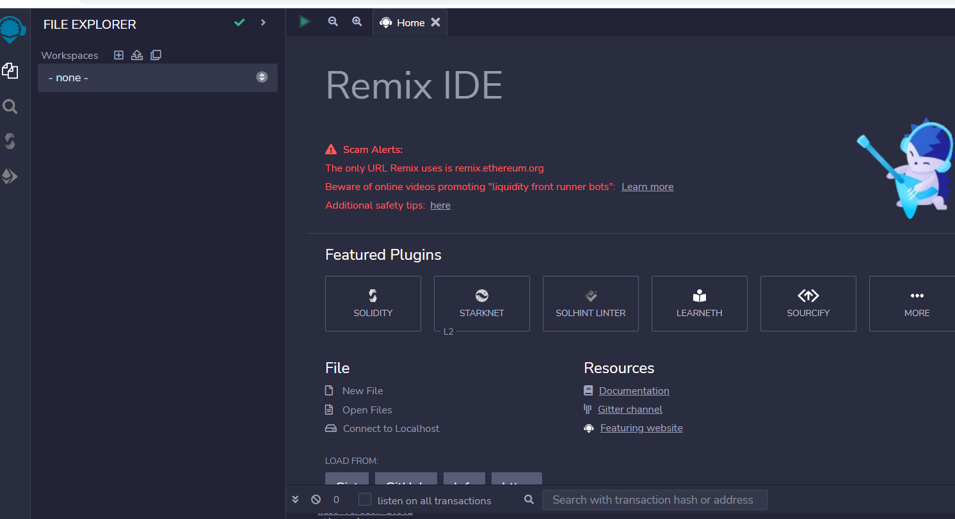

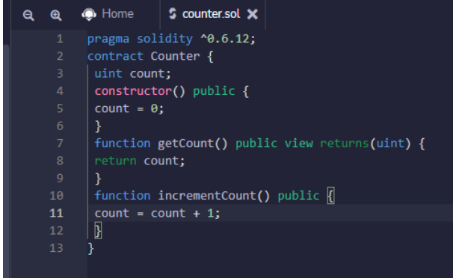

2. Now Compile and go to Deploy and run transaction and click on deploy program

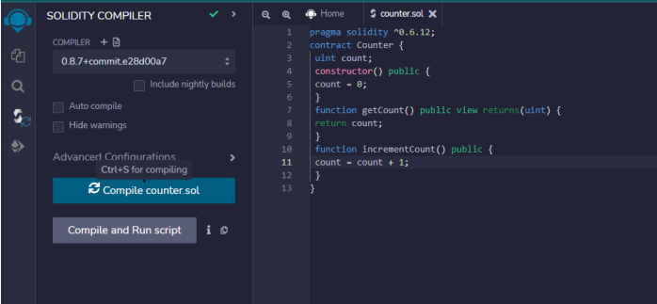

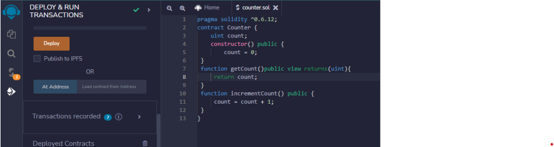

**Output:-**

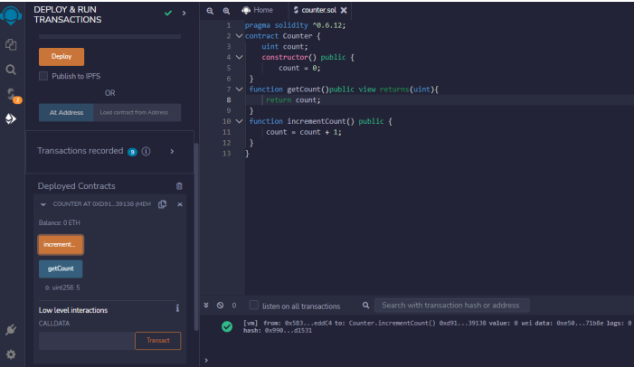

**Deployed Contracts:**

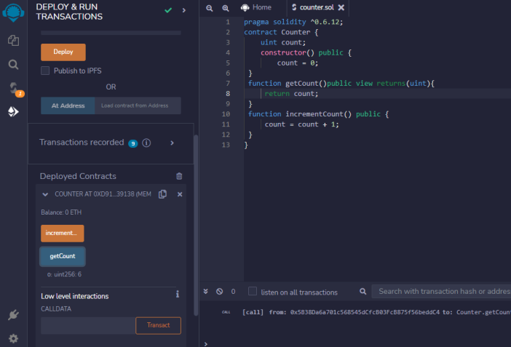

**B. To Create and Explore Types of Variables with Varying Data Types in Solidity Programming (Variables)**

**File name as variable.sol**

**CODE:-**

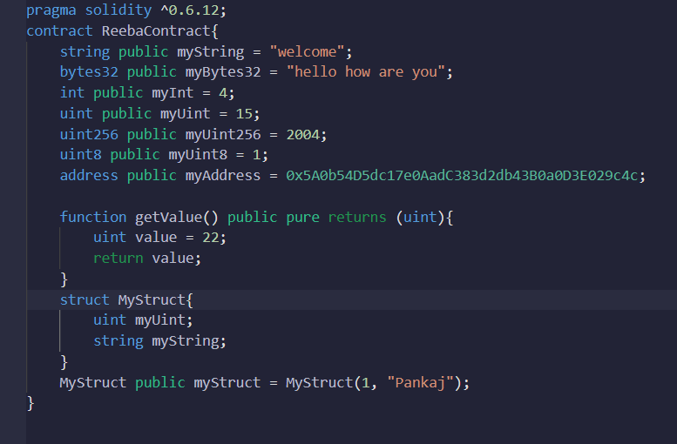

**Output:**

**Deploy output:**

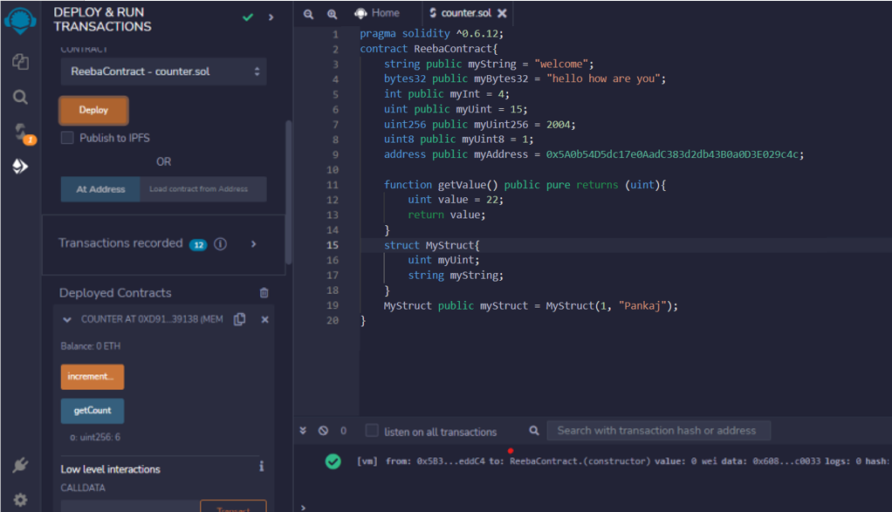

**Deployed Contracts:**

